FACULTY EVALUATION
Programme Name: Sisters’ Blended Value Program (Sbvp)Social Entrepreneurship Development Program (SEDP) Advance Module 3 Zambia (26th January 2026 - 30th January 2026)
Session: Funding Sources
Faculty Name: Dr. Chilumba Bwalya
No. of Respondents: 12
No. of Participants: 12
Evaluation Parameter | (%) Individual Score | (%) Programme Average
Punctuality (Commencement and Completion of Sessions) | 93 | 95
How well do you understand the core concepts presented? | 95 | 91
Rate your confidence in applying the new skills learnt | 93 | 92
Degree of Faculty preparedness for the sessions | 100 | 95
Content and methodology of the program | 98 | 96
Quality of class and group discussions | 100 | 95
The information presented in the course is relevant to my work (ministry) | 83 | 92
Average scores | 95 | 94

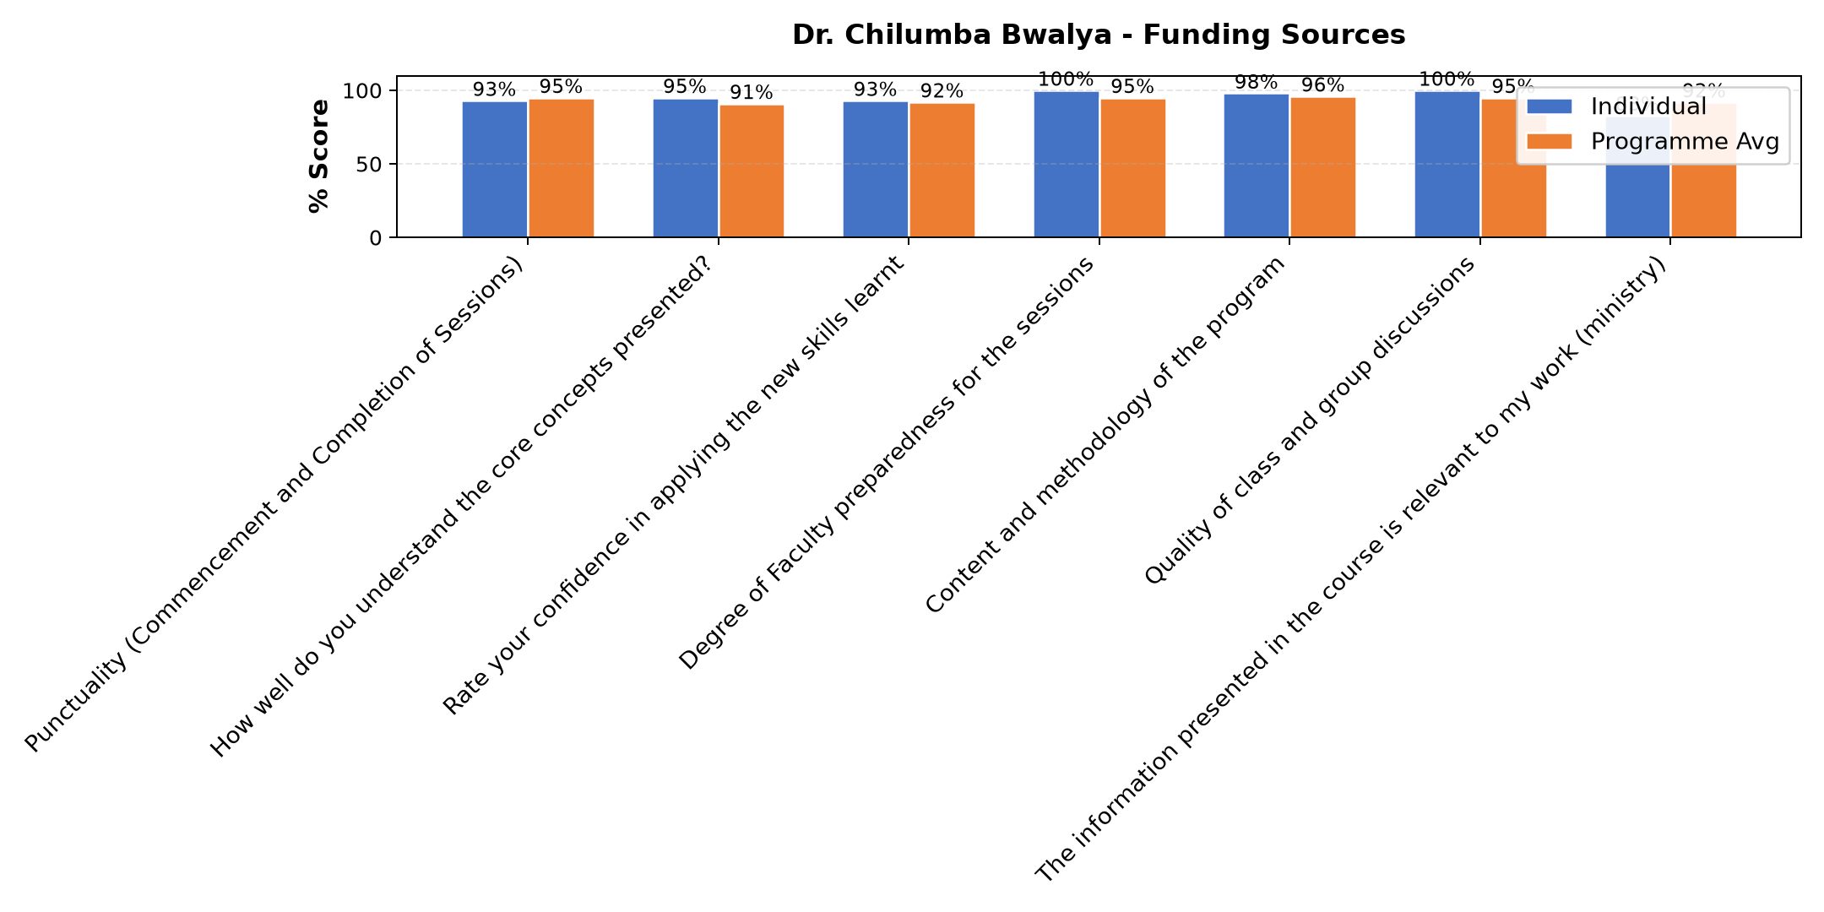

Comments & Feedback
- • Thank you helped me to know how I can do better
- • The topic was very relevant and helpful
- • He has his own stale of teaching.
- • Excellent presentation
- • Am going to put what i have ben told into action and to present Excellent abed
- • Very helpful
- • All this that i have told in this course,i have to go and put it into action
- • The sessions were so interesting
- • We learnt were to go for funding and their requirements, we looked at the scale were we are as an enterprise, what we have done and what needs to be done.
- • We need to involve other stakeholders as to learn from them. Not to give up
- • When i checked the topic i was very happy unfortunatly i couldnt follow upto 6he end.
- • Your insight was great, very effective to our Enterprise especially in dealing with
SUBMITTED THROUGH:
SBS Evaluation Automation System

